Metering Installation Error Report

(Data source: explore_1.xlsx. Error calculated: Fri Mar 13 13:58:08 2020.)
The error calculated for the given load profile is +0.81 %.
The expanded uncertainty at an estimated 95% level of confidence is 0.22 %.
The uncertainty interval extends from +0.59 % to +1.03 %.

Installation error over the phase and current ranges that match the load profile.
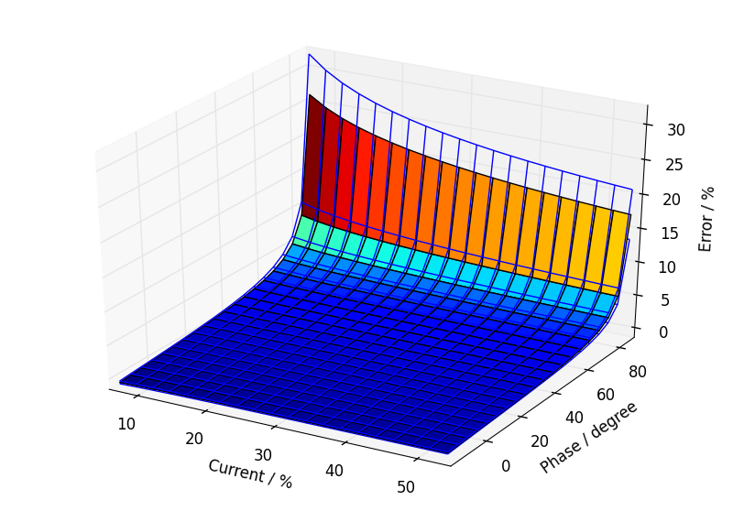

Annual load profile used for this error calculation.
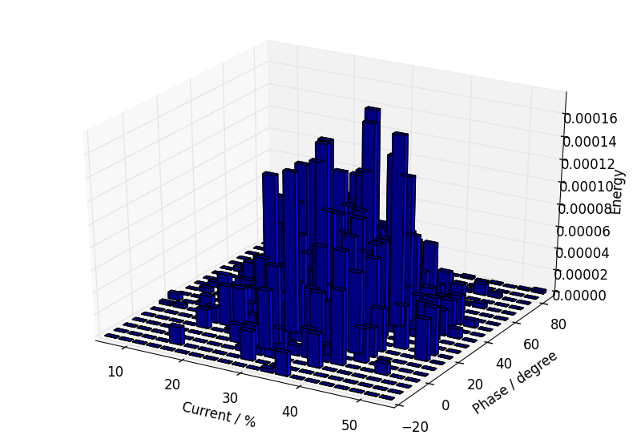

Component calibration data with calculated fits over the calibration ranges.

Current Transformer.
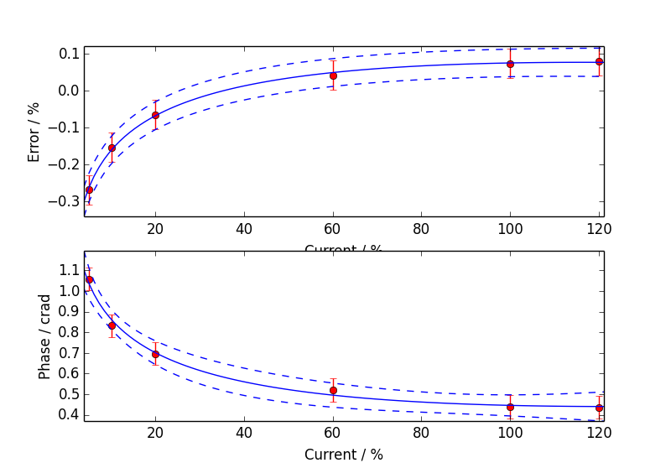

Voltage Transformer.
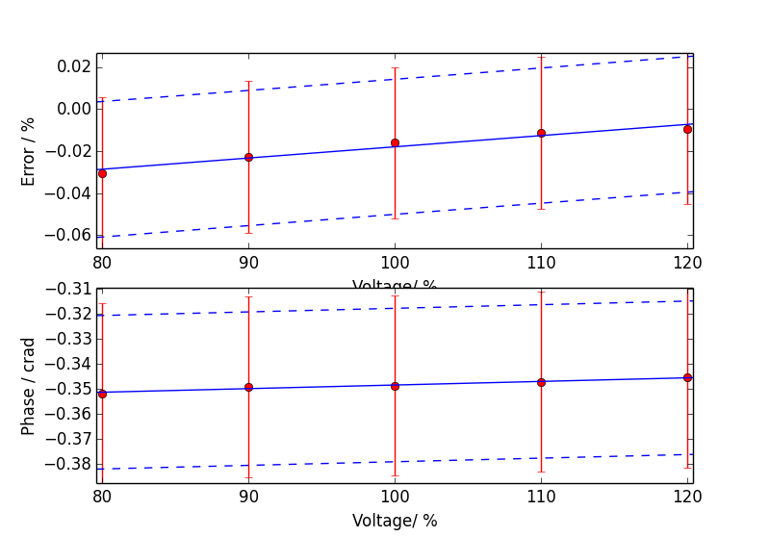

Meter.
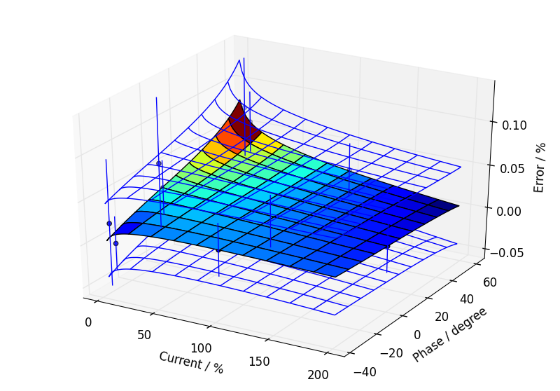

Additional Information

Uncertainty Contribution Summary
Uncertainty contribution by component as a percentage of total variance, Meter: 13 %, CT: 50 %, VT: 37 %.

Text Output From Calculation Process
Meter data
Fit has lower uncertainty than expected from calibration data, so type B component added.
CT ratio data
Fit has lower uncertainty than expected from calibration data, so type B component added.
CT phase data
Good fit.
VT ratio data
Fit has lower uncertainty than expected from calibration data, so type B component added.
VT phase data
Fit has lower uncertainty than expected from calibration data, so type B component added.

Load phase limited to 89.9 degrees maximum
Max current = 54.83 %, Min current = 5.53 %, Max phase = 89.90 degrees, Min phase = -20.56 degrees

Budget for overall error by coefficients

0.81, u=0.11, df=98.4
a2 CT_e: 0.0666241
a2 CT_p: 0.0568575
a0 VT_e: 0.0515479
a1 VT_e: 0.05104
CT calibration burden: 0.0506465
Site CT burden: 0.0506465
a0 VT_p: 0.0440408
a1 VT_p: 0.0436068
a0 CT_e: 0.0418284
a0 CT_p: 0.0357368
Meter temperature coefficient: 0.0357071
Meter harmonic dependence: 0.0282843
Site harmonics: 0.0282843
VT calibration burden: 0.0279816
Site VT burden: 0.0279816
Site voltage: 0.0224261
Meter voltage dependence: 0.0212132
b0 meter: 0.0202546
b0 CT_e: 0.0183737
a1 CT_e: 0.0166465
b0 VT_e: 0.0163636
a1 CT_p: 0.0141734
b0 VT_p: 0.0133987
Site frequency: 0.0133681
Meter frequency dependence: 0.0132583
a2 meter: 0.0129563
a3 meter: 0.0127323
Site temperature: 0.0101376
a0 meter: 0.00824024
a1 meter: 0.00271207
CT temperature coefficient of phase: 0.000710804
VT temperature coefficient of phase: 0.000406428
CT calibration temperature: 0.000197522
VT calibration temperature: 0.000109128
VT temperature coefficient of error: 2.4479E-05
CT temperature coefficient of error: 1.94792E-05

